Insurance Management System
Database Documentation Report using Python and MySQL.

Software Requirements Specification-2

Team Members:
1. Amal Kakkat – Roll No: 12 – Sem :4 – AIML
2. Ashish Rajan - Roll No: 24 – Sem :4 – AIML
3.Mohemmed Rikas - Roll No: 43 – Sem :4 - AIML
4.Kiran Sunil - Roll No: 39 – Sem :4 - AIML
5. Goutham Sankar – Roll No: 33 – Sem :4 –AIML
6.Anandhakrishnan .KB – Roll No: 18 – Sem :4 – AIML

Submitted To : Magnory PVT

Facilitator : Anupama

Institution : Sree Buddha College of Engineering , Pattoor
Date:18/02/2026

1. Introduction
The goal is to create a centralized platform where administrators can manage insurance products and clients can purchase/track policies. Using Python (via frameworks like Flask or Django) ensures rapid development, while MySQL provides a robust relational structure for sensitive financial data .This document explains the database creation and working of the Insurance Management System.
The system consists of four major modules: Users, Policies, User_Policies, and Claims.
Each module interacts with MySQL using Python.

2. System Architecture
- The system follows a classic Client-Server architecture.
- Frontend: HTML/CSS/JS or a Python-based GUI (Tkinter/PyQt).
- Backend: Python (Logic processing, MySQL connectivity via mysql-connector-python).
- Database: MySQL (Storage of users, policies, and claims).

3.Functional Requirements
- The system shall allow new users to register with valid details.
- The system shall authenticate users using username and password.
- The system shall allow administrators to add, update, and delete insurance policies.
- The system shall allow users to view available insurance policies.

4.Non-Functional Requirements
- Security: Passwords must be hashed (using libraries like SHA256) before being stored in MySQL.
- Data Integrity: Use MySQL transactions to ensure that if a payment fails, the policy isn't issued. Performance:
- Performance: Python's database queries should be optimized using indexing on user_id and policy_id.

5. USERS Module
Purpose : User Management
● Registration/Login: Secure authentication for Customers and Admins.
● Profile Management: Users can update contact details and view their history.
Stores registered user details.
Main Fields:
- user_id (Primary Key)
- username
- email
- password
Operations:
- Add user
- View users
Description of the table:
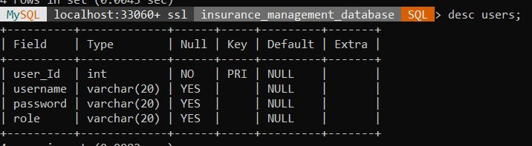
Login page :
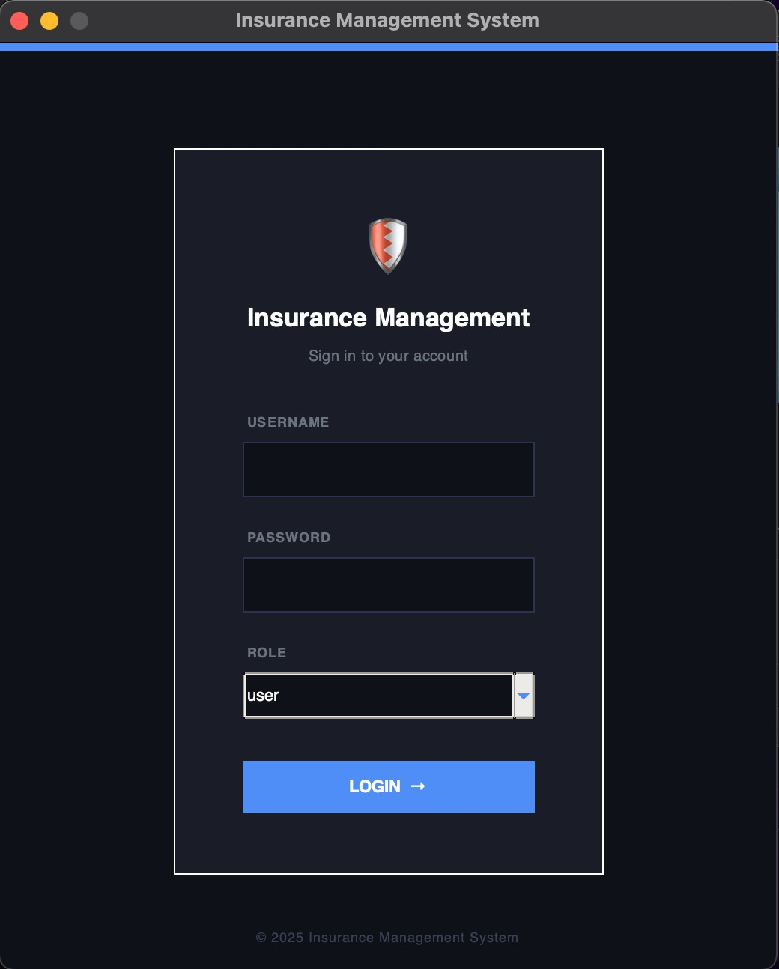
Admins panel:
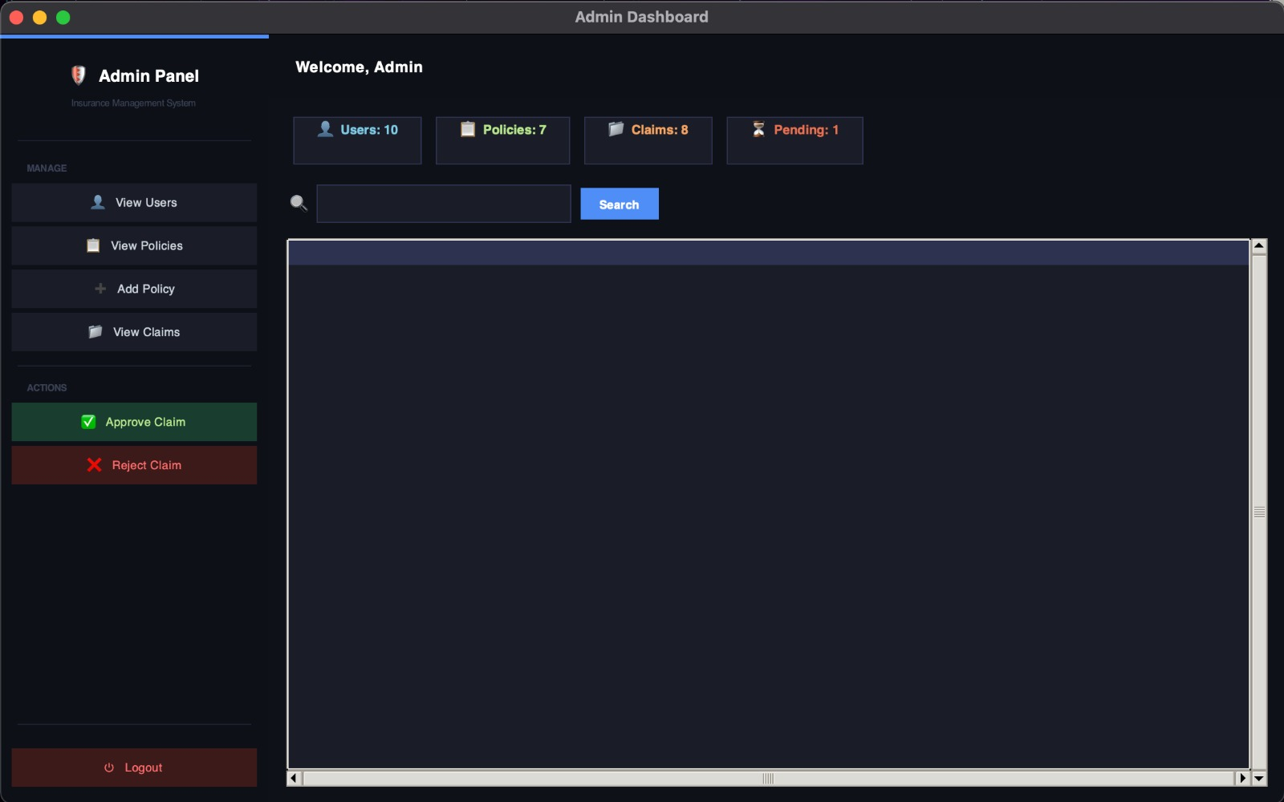

Agents panel:
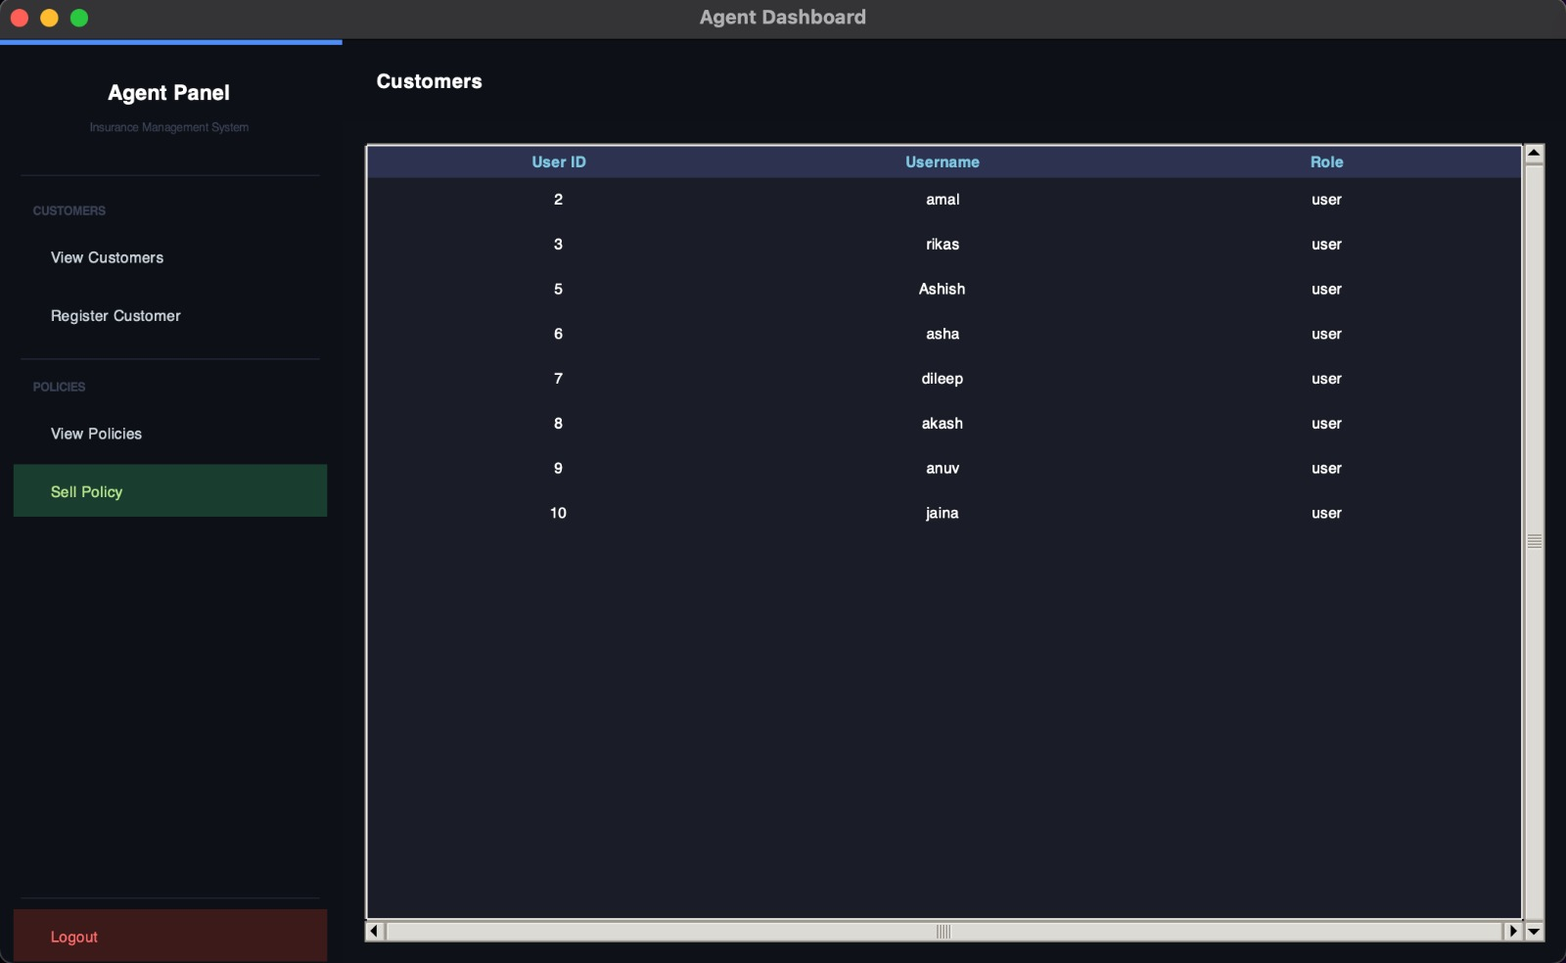

3. POLICIES Module
Browse Policies: View available insurance types (Life, Health, Auto).
● Purchase Policy: Link a user ID to a policy ID in the database.
● Calculate Premium: Python logic to calculate costs based on user age, coverage, and risk.
Main Fields:
- policy_id
- policy_name
- premium
- coverage
Operations:
- Add policy
- View policies

Description of the table:
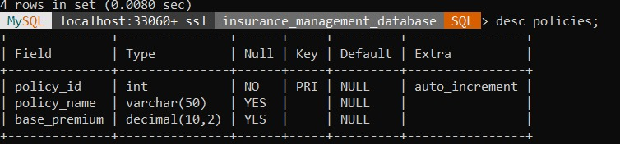
4. USER_POLICIES Module
Purpose: The Policies module stores and manages all insurance policy details offered by the company.
It allows administrators to create, update, and monitor available insurance plans.
Maps users with purchased policies.
Main Fields:
- purchase_id
- user_id
- policy_id
Operations:
- Purchase policy
- View purchased policies
Description of the table:
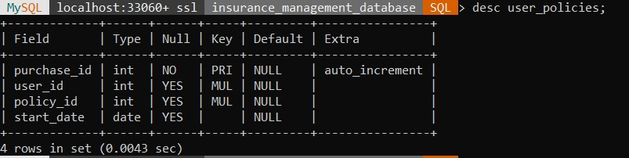

User panel:
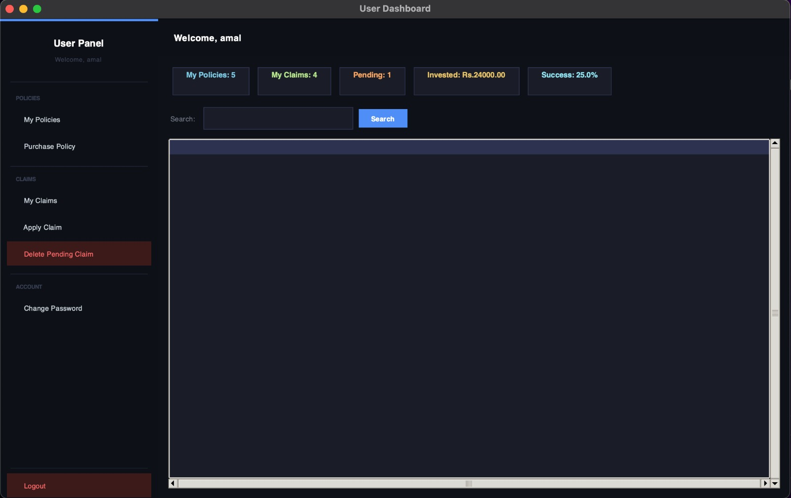

5. CLAIMS Module
- File a Claim: Users upload details regarding an incident.
- Claim Status: Real-time tracking (Pending, Approved, Rejected).
Purpose : Handles insurance claims.
Main Fields:
- claim_id
- user_policy_id
- amount
- status
Operations:
- Add claim
- View claims
- Update claim status

Description of the table:
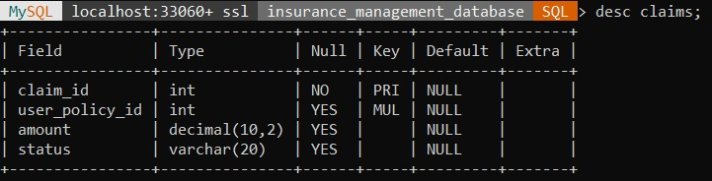
6. Database Relationships

- USERS → USER_POLICIES → POLICIES
USER_POLICIES → CLAIMS
- The USERS table is related to the USER_POLICIES table through user_id.
- One user can purchase multiple policies (One-to-Many relationship).
- The POLICIES table is related to the USER_POLICIES table through policy_id.
- One policy can be purchased by multiple users (One-to-Many relationship).
- The USER_POLICIES table acts as a junction (bridge) table between USERS and POLICIES.
- Foreign keys are used to maintain referential integrity.

7.Entity Relation Diagram
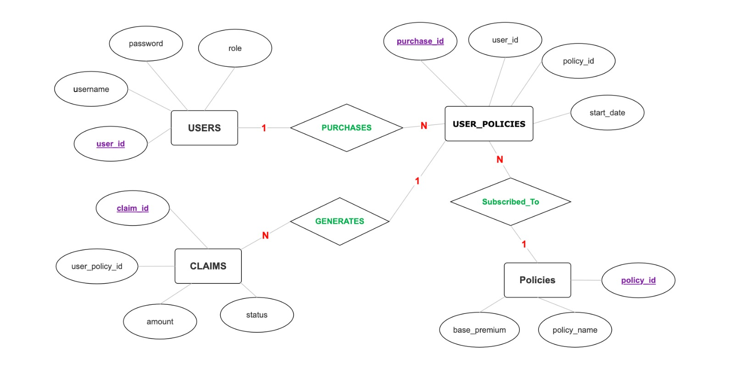

8. Conclusion
The Insurance Management System database is designed using MySQL and Python.
All modules work together to provide a complete claim processing workflow.
This system supports CRUD operations and maintains data consistency.

